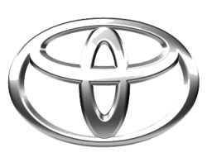
TOYOTA
TOYOTA MOTOR CORPORATION
I. TOYOTA-CHO TOYOTA. AICHI, 471—8571(HEAD OFFICE)
or 471 8572 (Research 5 Development Group) THAILAND
TEL: +81-565-28-212

GSO Conformity Certificate CCR No. 530361
Motor Vehicles
Manufacturer: Toyota Motor Corporation
Country of Origin: JAPAN, Country of Production: JAPAN
To: GCC Standardization Organization (GSO)
We hereby certify that the vehicles manufactured by Toyota Motor Corporation
* Type: TOYOTA LAND CRUISER GXR V6 4.0L SUV 4WD 5Doors
* VlN number: JTMAUCBJ2S4094572
* Model Year: 2025 * Produced in and after: Month 6 Year 2025
* Category: Multipurpose Vehicle
Will satisfy the G50 Technical Regulations Nos: 34:20o7, 3s:2007, 36:2005, 37:2012, 38:200s, 392005, 40:2011,42:2015, 48:1984, 51:20o7, 52:2007, 53.2007, 9611988. 9721988, 9811988, 9921988,13522007, 13622007. 29021994. 4119:1994,42o:1994,421:2005,422:200s.1040:20001041:2000,1042:2000,1053:2000,1503:2010,1598:2002,1624:2002,1677:2003,1708:2o0s,1780:2010,1781:2006,1782:2008,1783:2006,1784:2o0e.Gsolso1585:2008,GSO lSO 3537:2008, GSO 150 3538:1997, G50 ECE13H:2012,GSO ECE13H-1:2012,GSO ECE13H-2:2012,GSO ECE 13H-3:2012, GSO ECE13H-4:20l2, GSO ECE13H-S:2012,GSO ECE 13H-6:2012 and the standards in the country of origin accepted by GSO in the case that no GSO technical regulations and standards are available.
All the essential technical data are as follows:
1. Weights
a. Maximum Vehicle Weight: 3350 kg b. Curb: 2580 kg
c. Maximum Axle Weight: Front: 1580 kg Rear: 1950 kg
2. Dimensions
a. Length: 5145 mm b. Width: 1980 mm
c. Height: 1890 mm d. Wheelbase (Fl R1) 2850 mm e. Track: Front: 1665 mm Rear: 1665 mm
3. Type of chassis and body: Body-on-frame
4. Number of Passengers: 7(Including the Driver)
5.Engine: Petrol a. Cylinders: 6 b. Displacement: 3982cc c. Air intake: Naturally Aspirated
d. Net Engine Power: 202 kW at 5600 rpm Pollutant Limit comply with Euro 4 standards.
6. Transmission: Automatic

7. Brakes a. Service Brakes: Hydraulic b. Emergency Brakes: Combined with the service brake
8. Fuel Economy a. Motor Vehicle Class: SUV b. FE (CAFE) Combined: 09.7 km/L - Good
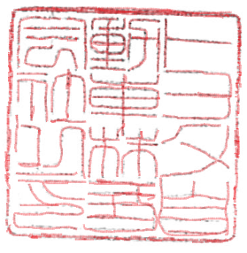
9. Any other information or local standards to be compiled: Also comply with the National regulations for member countries mentioned in the Annex of the list of Technical Regulations for MV 2025MY-D3, when exporting to those countries. .
Keiko Yanagi
general Manager Regulation &Certiﬁcation Division
11 OCT 2025

